Pete & Frances Pfau Benefit
Friday, September 7, 2018 at 6:00 pm
St. Mary’s Family Center, 400 Charlos Street, Stevensville
Dinner: Pulled Pork with Traditional Fixings
Live Auction, Silent Auction and Raffles

This benefit will help defray medical costs faced
by this long-time Bitterroot Valley couple.
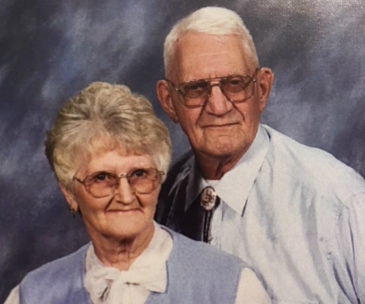

Pete and Frances Pfau are longtime residents of the Bitterroot Valley. An Army Veteran of the Korean War, Pete worked in a variety of fields including farming, ranching, long haul trucking, school and charter bus driving, banking, and owning a restaurant. He did whatever was needed to raise his children and provide for his family with his loving wife Frances, always at his side supporting him in every endeavor. Pete and Frances are active in the Catholic Church and have devoted their lives to service in the community. Pete is a member of the Knights of Columbus and has given countless hours of volunteer time over the years.

In recent years Pete has been in gradually failing health, requiring many doctor and hospital visits that have added up and placed a burden on Pete and Frances. In just the last six months, they have been financially overwhelmed with expenses from hospital stays including intensive care, emergency room visits, cardiac care, ambulance transportation, rehabilitation stays and services, and follow up care.

Donations of auction and raffle items are currently being accepted. For more information, please contact Mike Bradt at 406-531-7733 or Dora Bradt at 406-360-2360; doraebradt@gmail.com

To make monetary donations go online to the Pete and Frances Pfau Benefit page at 406familyaidfoundation.org and click on the “Donate” button or send a check payable to:

406 Family Aid Foundation
573 Grandview
Stevensville, MT 59870.

Please note Pete and Frances Pfau in the memo line of your check.

